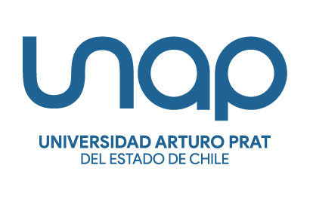
XXIV SONAPLES CONGRESS 2027
January 20, 21, and 22, 2027
Iquique – Chile

CLASSROOMS WITHOUT BORDERS:
INNOVATION, DIVERSITY, AND LINGUISTIC JUSTICE IN LANGUAGE TEACHING

Speaker Proposal

Indicate subtheme (Mark with an X)

LINE 1: Diversity, Linguistic Justice and Educational Policies
Linguistic justice, translanguaging and decolonization
Revitalization and preservation of ancestral languages ​​and training of traditional educators
Vernacular languages
Indigenous languages, diversity, migration, inclusion and gender
Language policies and internationalization
Linguistic landscape, public space and disputes over the visibility of languages ​​/ Language, affectivity and reparation in contexts of linguistic loss

LINE 2: Pedagogical Innovation, Technology and Teaching-Learning Processes.
Generative AI and language learning: ethics, teaching-learning processes and evaluation
Neuroeducation, metacognition, and empirical evidence in the classroom
Special educational needs and language learning/teaching
Critical literacies, multimodality and new media
Rethinking English teaching methods: strategies for meaningful teaching in the 21st century

LINE 3: Teaching, Affectivity and Identity
Identity, emotion and motivation: the affective turn, socio-emotional education, linguistic anxiety and agency
Teacher development: reflective practice, teacher professionalism and ecological approach

Speaker proposal

If you intend to present more than one proposal, please fill in different forms.

Title of presentation:
Check the box to select the type of session:
- Presentation
- Workshop
- Poster
- Round Table

Presenters
Write the name(s) of the presenter(s)
Name of presenter 1:
Email address:
Phone number:
Country:
Name of presenter 2:
Email address:
Phone number:
Country:
Name of presenter 3:
Email address:
Phone number:
Country:

Fill in this form with the information required
Presentación
Title of the presentation:

Name of the institution:

City: | Country:
Abstract: (80 words maximum)

Proposal (400 words maximum)
(Proposals of presentations should have the following structure: introduction, methodology, results, and conclusions)

Biographical Statement: (30 words maximum)
Send your complete proposal to: sonaples2027@gmail.com
(Please, send your proposal in a Word document)

Important dates:

Deadline for proposal submissions: 31st August, 2026

Results of proposal evaluation: 14th September, 2026

